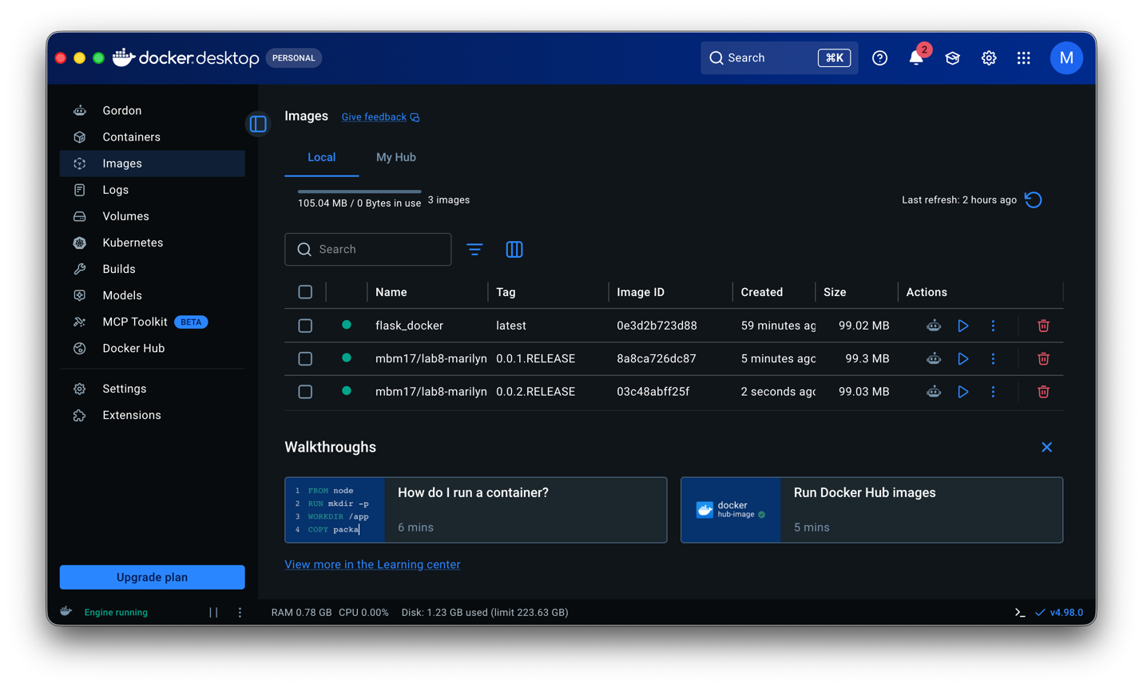

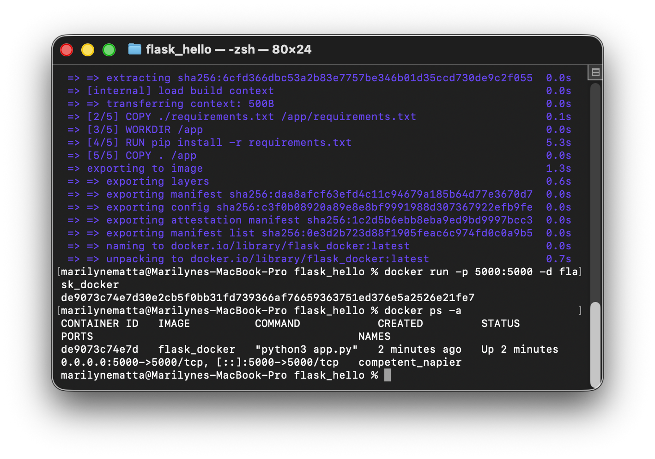
Figure1: Activity1_docker_ps
This command displays all Docker containers, including running and stopped containers. It shows information such as the container ID, image name, status, ports, and container name.

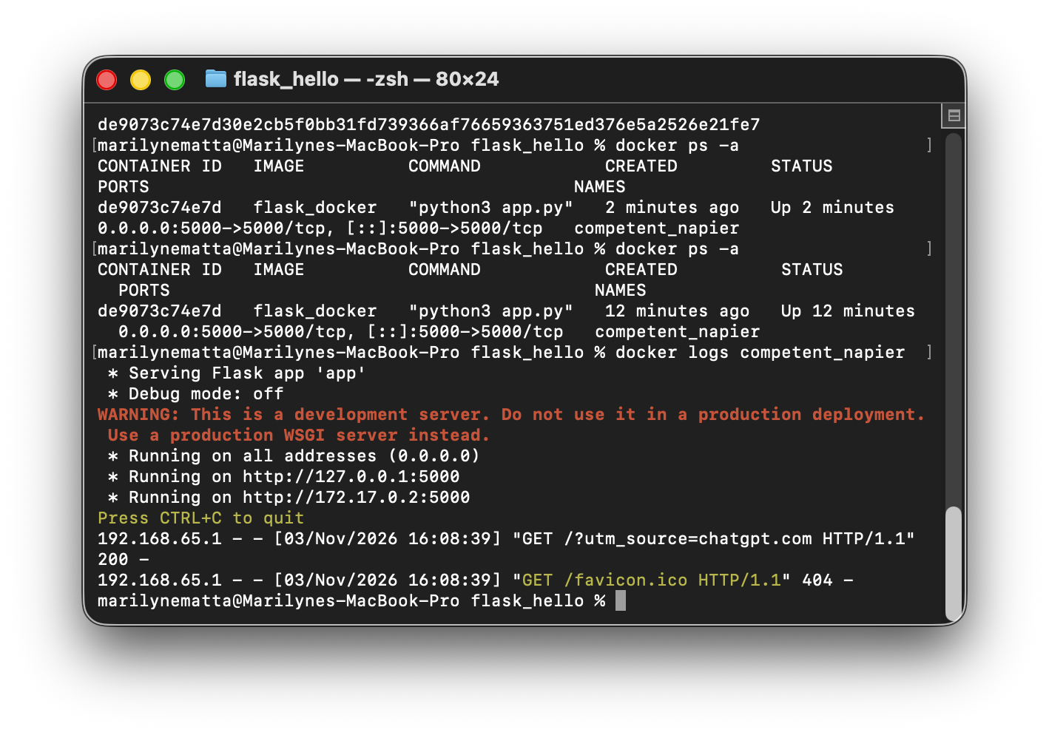
Figure 2 : Activity1_docker_log
This command displays the logs and messages generated by a specific container. It helps us check if the application is running correctly and identify errors. In my case, it showed that my Flask application was running on port 5000 and successfully received an HTTP GET request.

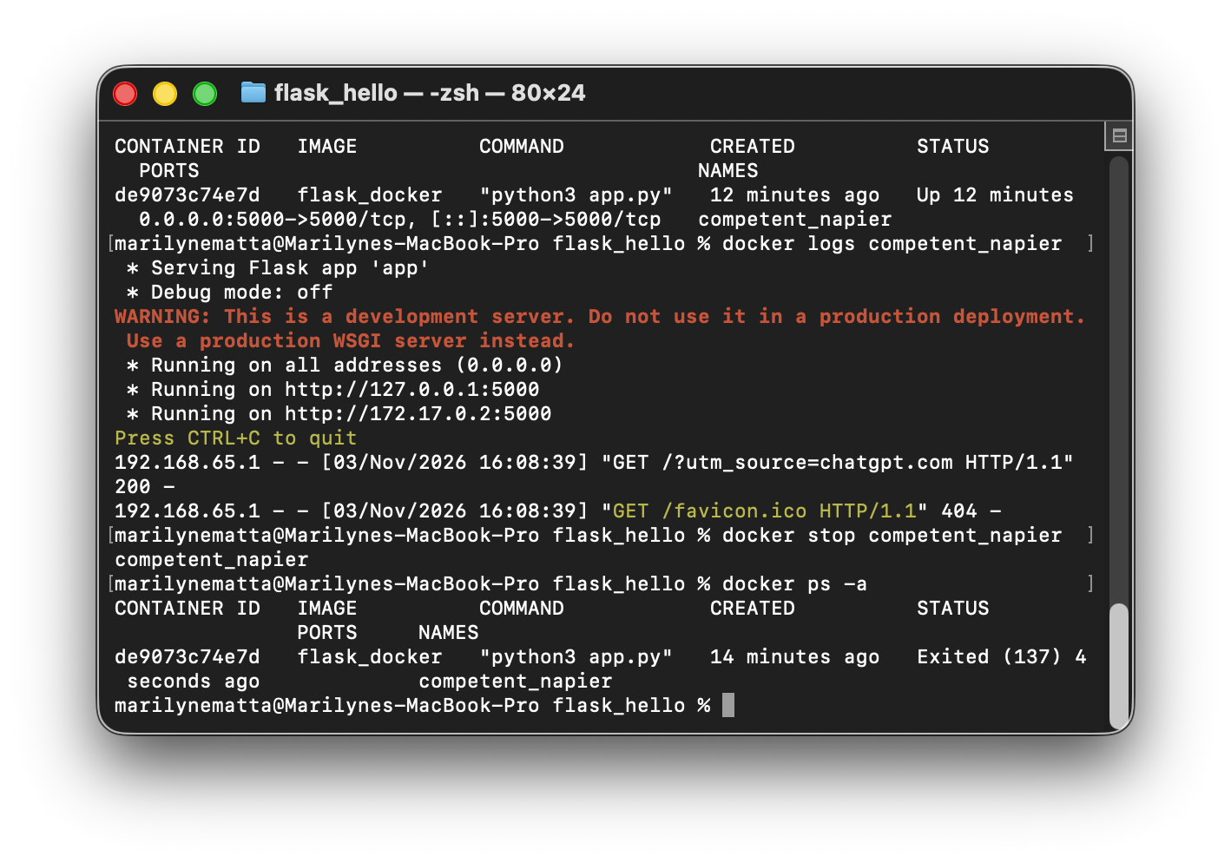
Figure 3 : Activity1_docker_stop
This command stops a running Docker container. The container is not deleted, so we can restart it later if needed.

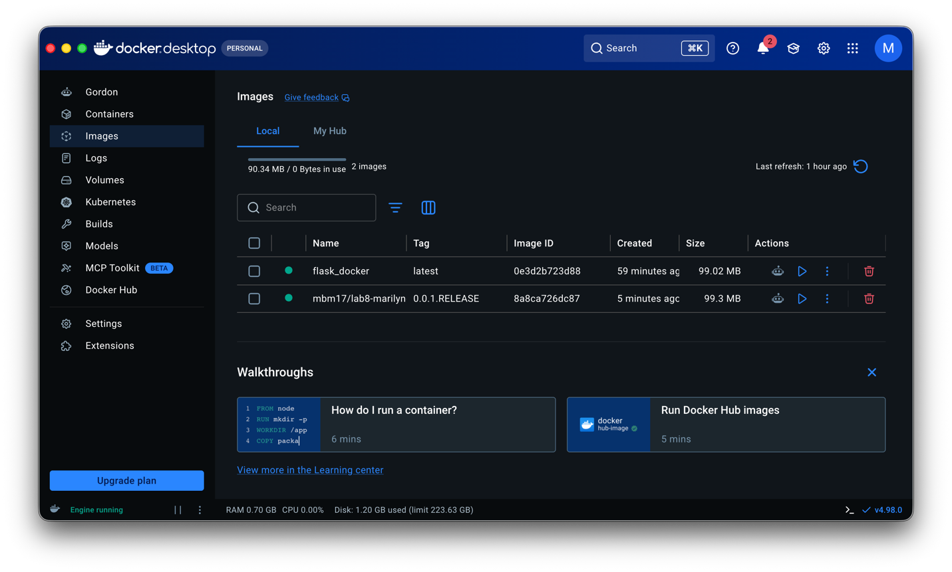

Figure 1 : Activity2_Image1
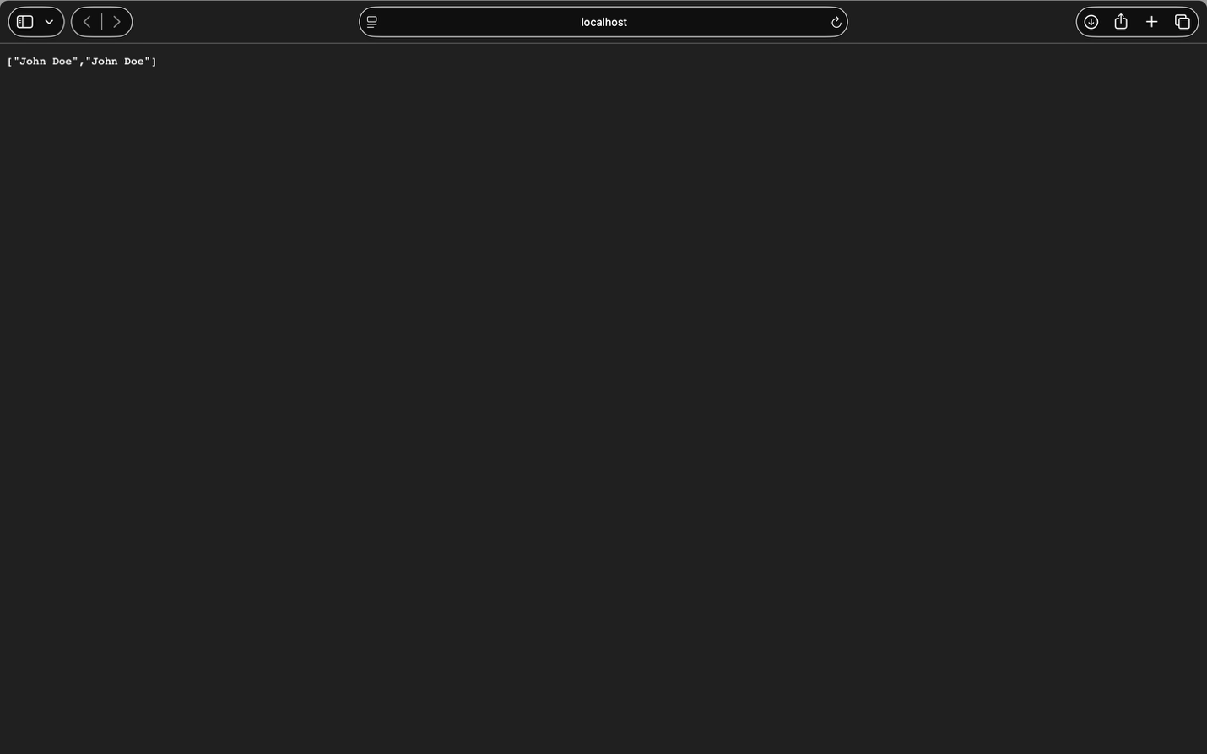
Figure 2 : Activity2_Image2_API

